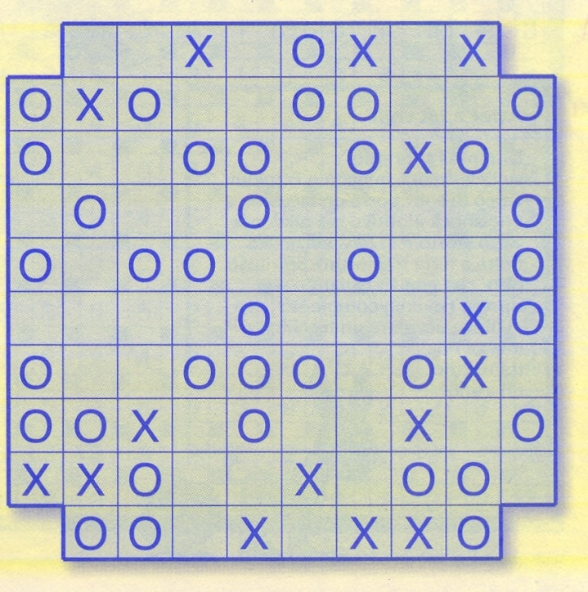 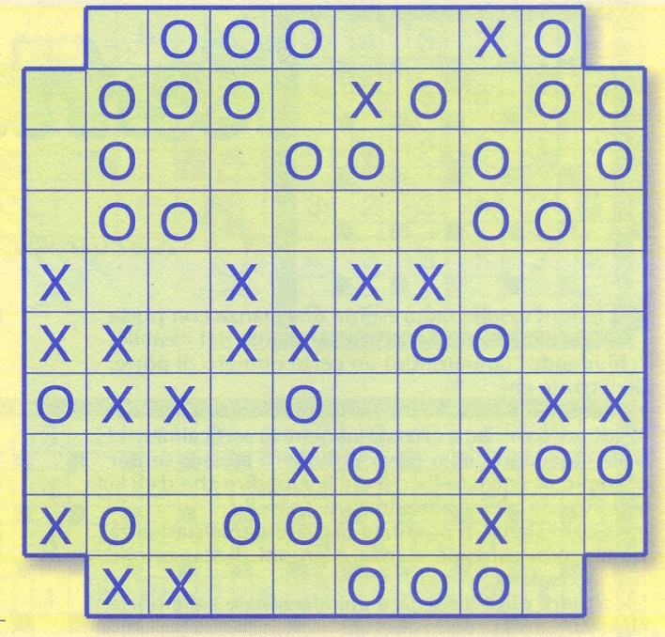

**Mai 4 interattivi**

|  |  |  |  |  |  |  |  |  |  |
| --- | --- | --- | --- | --- | --- | --- | --- | --- | --- |
|  |  |  |  |  |  |  |  |  |  |
|  | **O** | **X** |  | **O** | **X** | **X** | **O** | **O** |  |
| **X** | **O** | **X** |  |  | **O** |  | **X** | **X** | **O** |
| **X** | **X** |  |  | **X** | **O** |  |  | **X** | **X** |
| **X** |  | **X** |  |  | **X** |  |  | **O** |  |
|  |  | **X** |  |  |  | **O** |  | **O** |  |
|  |  |  | **O** |  | **O** | **X** |  |  | **O** |
| **O** |  |  | **X** |  |  |  |  |  | **X** |
| **O** |  | **O** | **O** |  | **O** |  |  | **X** | **X** |
| **X** |  | **O** |  |  |  | **O** |  |  | **O** |
|  | **X** |  | **O** |  | **O** | **X** | **X** |  |  |
|  |  |  |  |  |  |  |  |  |  |