Riepilogo Corso Avanzato Allena…Menti 2018-2019

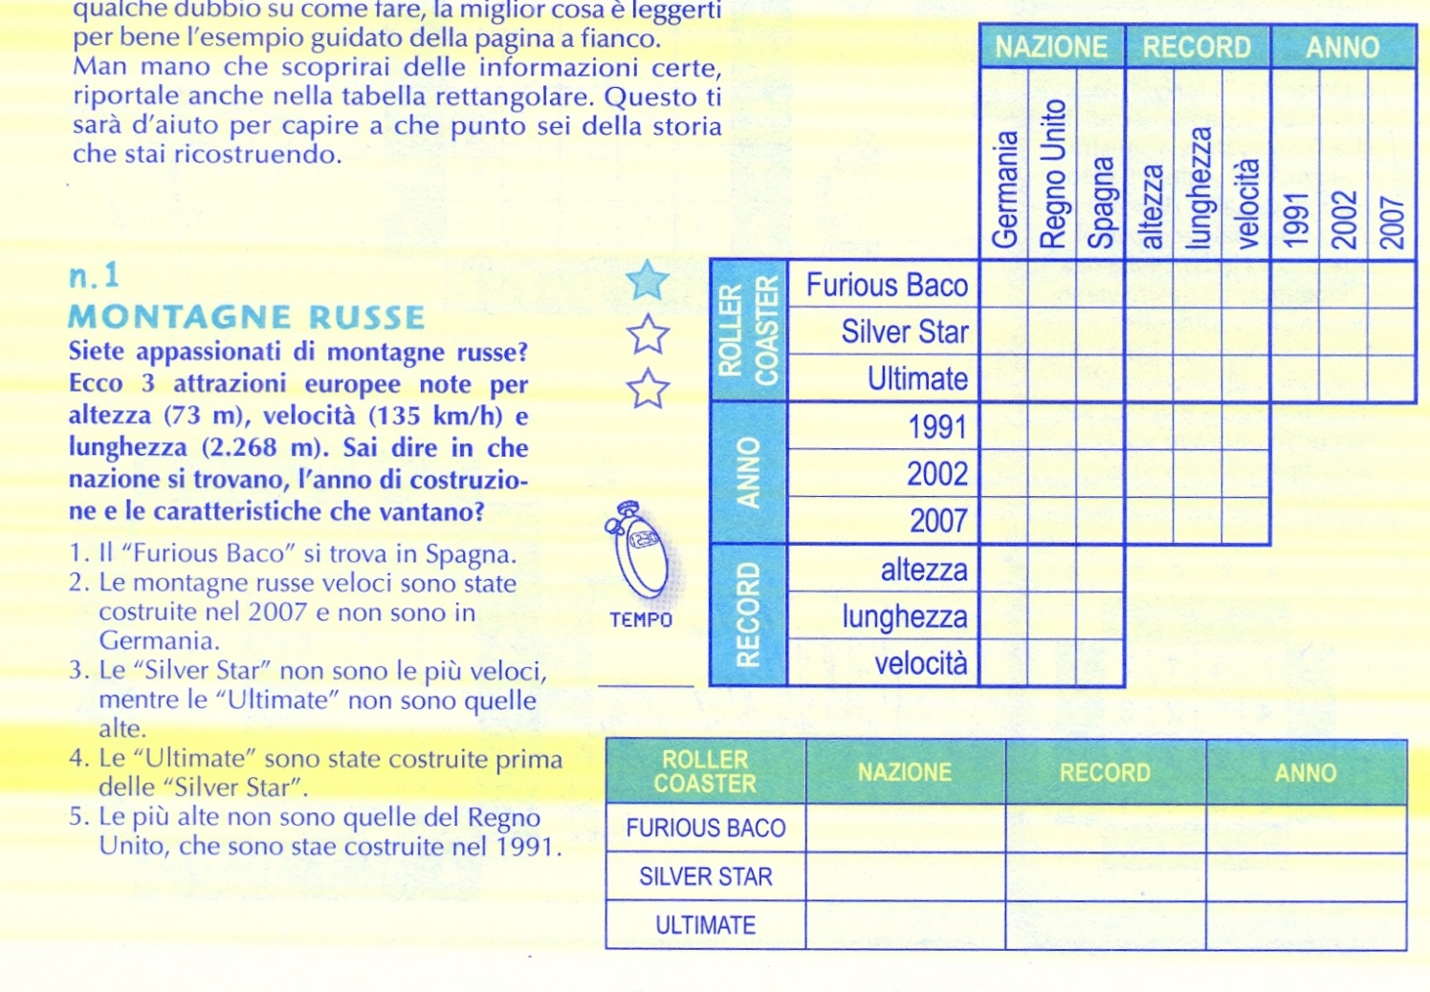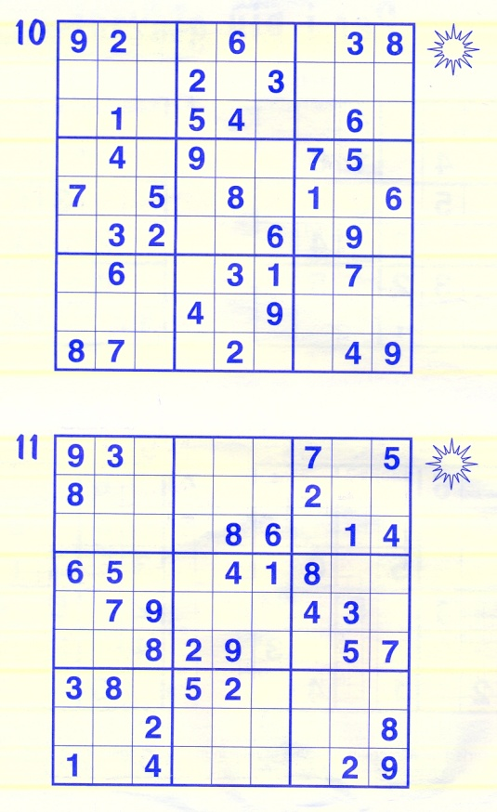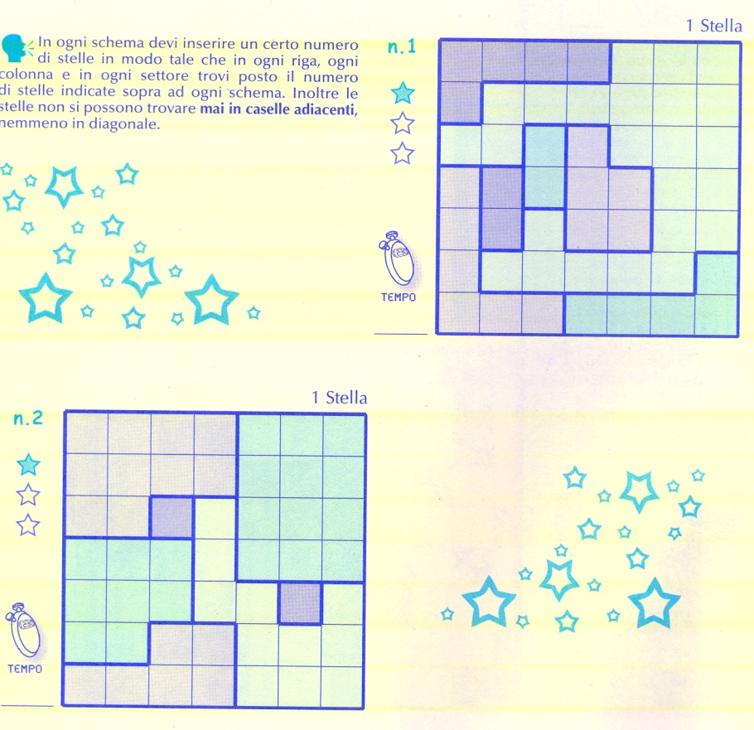

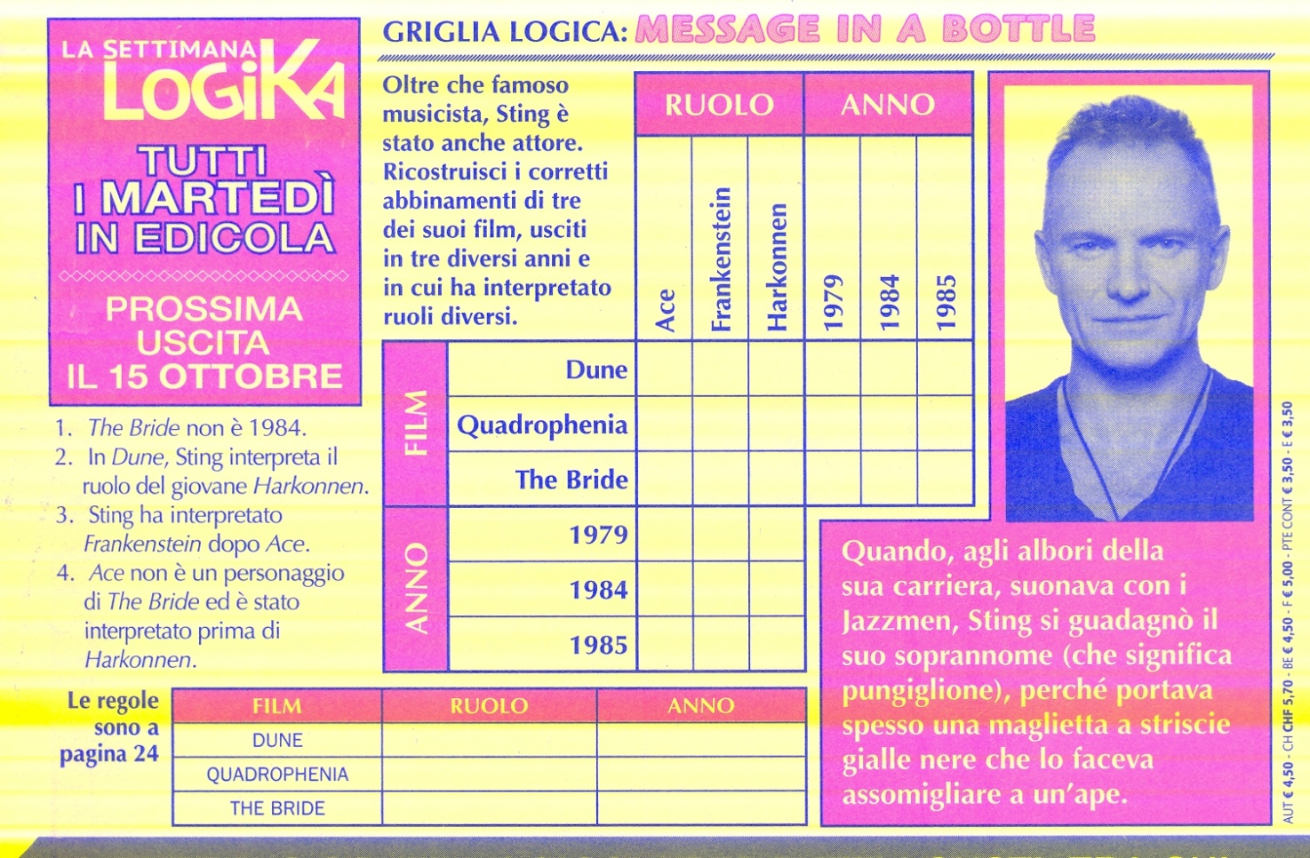

R

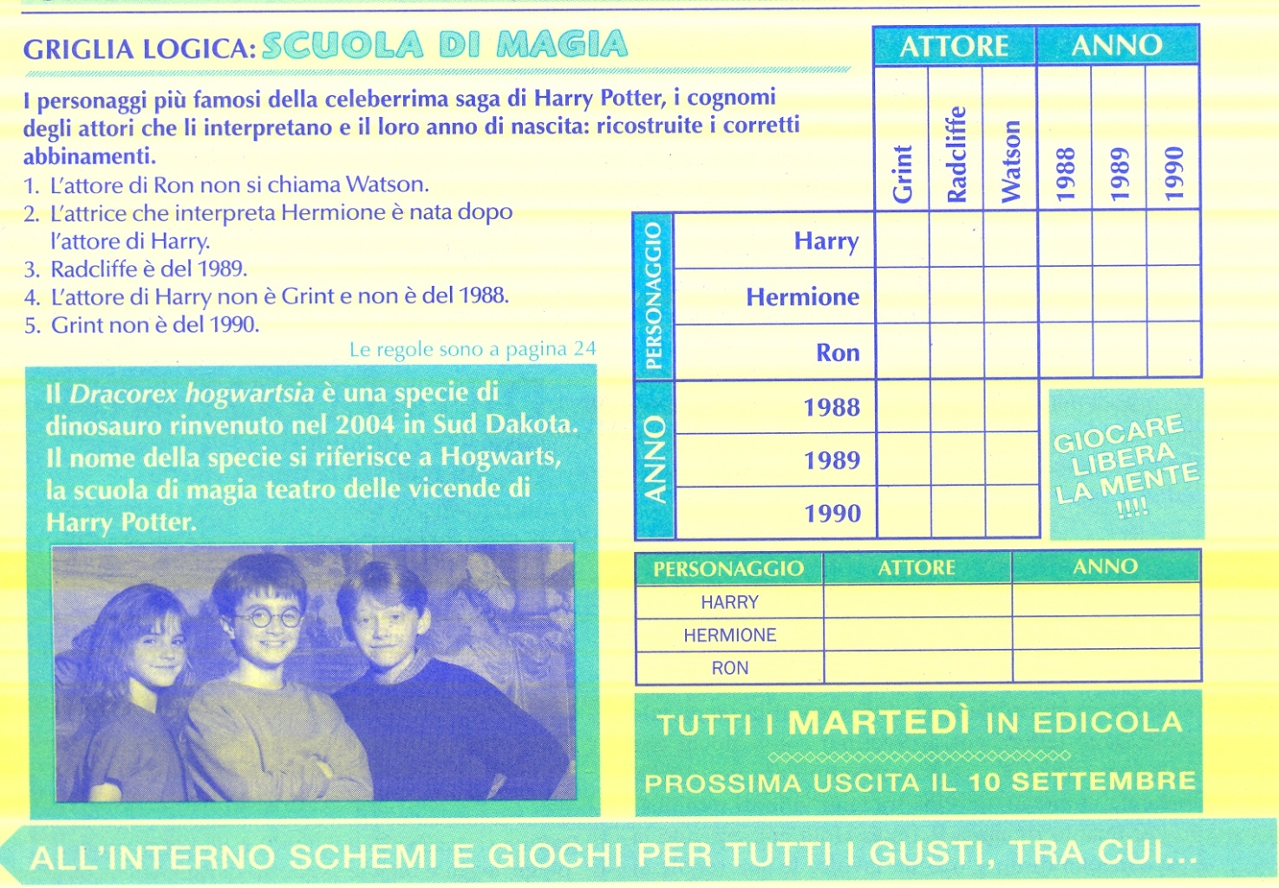

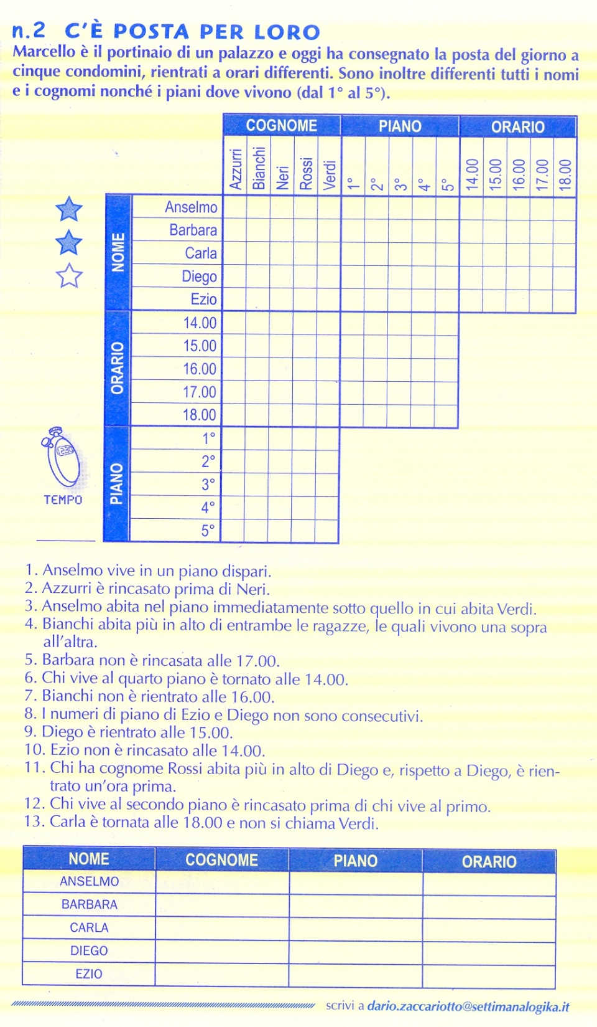

Campo minato

|  |  |  |  |  |  |
| --- | --- | --- | --- | --- | --- |
| 2 |  | 3 |  | 2 | 1 |
| 3 |  |  | 2 |  |  |
|  | 6 |  |  |  | 2 |
|  |  |  | 3 |  | 1 |
|  | 4 |  | 2 |  | 2 |
| 1 | 1 |  |  |  |  |

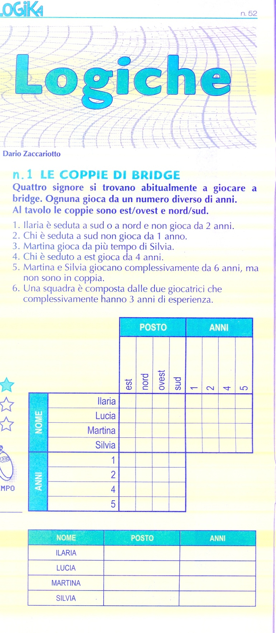Griglie logiche

Yin & Yang Quadrati latini

|  |  |  |  |  |  |
| --- | --- | --- | --- | --- | --- |
|  |  |  |  |  |  |
|  |  |  |  |  |  |
|  |  |  |  |  |  |
|  |  |  |  |  |  |
|  |  |  |  |  |  |
|  |  |  |  |  |  |

|  |  |  |  |  |
| --- | --- | --- | --- | --- |
|  |  | C3 | B |  |
| 1 |  | D |  | A2 |
|  |  |  |  |  |
| E |  | 1 | C | 3 |
| C2 |  | 4 | D1 |  |

|  |  |  |  |  |
| --- | --- | --- | --- | --- |
|  |  | E | 5 | C |
| A | 1 | C |  | B |
|  | B |  | A | 2 |
|  |  |  |  | 4 |
| E |  | 5 | B | 3 |

