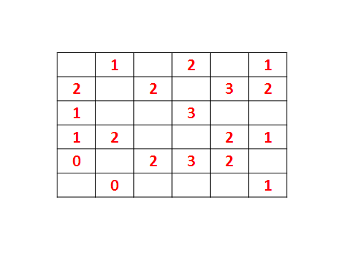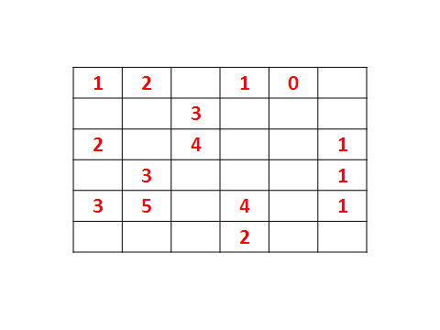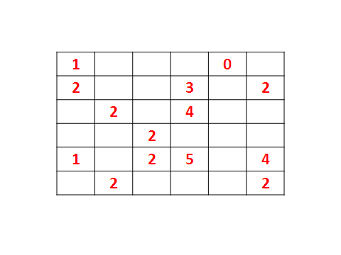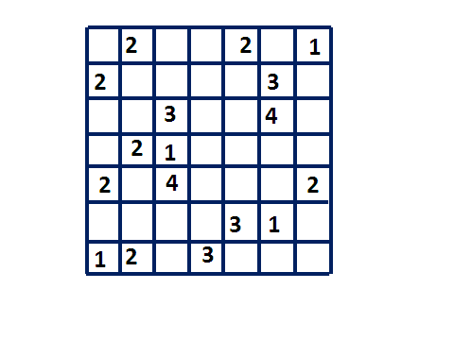

|  |  |  |  |  |  |
| --- | --- | --- | --- | --- | --- |
| **2** |  | **2** |  | **0** |  |
| **2** |  | **3** |  |  | **1** |
| **1** | **2** |  | **1** | **2** |  |
|  | **2** |  | **2** | **3** |  |
|  | **3** | **3** |  |  | **2** |
|  |  | **3** |  |  | **1** |